Th**e** S**t**or**y** of **t**he A**n**ts

*Michael Schwalen*

Una oración interrogativa termina con un signo de interrogación.

Are you feeling happy today?

Give me another sentence to type.2

tHESE SENTENCES ARE STUPID.2

am the one that has the test[1] tomorrow.

~~B~~

~~ill Gates is very rich.~~

Clocks intrigue me and others. Figure

I want to type another sentence.2/22/2020

**Maggie is a dog that is very good but also fuzzy, too.**

By this point the final sentence has terminated. ☺☹☺🖾🡩€÷©☯™≠≤≥👎♪♫☼►◄↕򴒥Ǯ ű├ ╞Ñä˟ɤ╞.ú¿đ, ä

Broughammed

The end

Did you mean: [***qwertyuiopasdfghjklzxcvbnm***](http://www.google.com/search?hl=en&sa=X&oi=spell&resnum=0&ct=result&cd=1&q=qwertyuiopasdfghjklzxcvbnm&spell=1)    
doesn’t pick

**Subsection 3 – The Michael Schwalen Rule**

A team is allowed to add a free agent that has already been on said team during the current season if no other team claims him within 24 hours of the email reclaiming the player.

[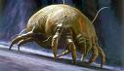](http://images.google.com/imgres?imgurl=http://blogs.redding.com/redding/mbeauchamp/archives/dust%20mite.jpg&imgrefurl=http://blogs.redding.com/redding/mbeauchamp/archives/2007/10/&usg=__PuUN5ImHRvXGPKQPxhdm0NW05M4=&h=260&w=450&sz=34&hl=en&start=6&tbnid=orU9VOvadVYAbM:&tbnh=73&tbnw=127&prev=/images?q=dust+mite&gbv=2&hl=en)[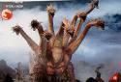](http://images.google.com/imgres?imgurl=http://www.godzilla.stopklatka.pl/hydra.jpg&imgrefurl=http://creative-deconstruction.com/blog/2008/10/20/a-list-of-captured-moments-innocuous/&usg=__XiTiJJ9dsAqdnEFrmZSq2-FiiME=&h=283&w=415&sz=29&hl=en&start=18&tbnid=PwrvW9_KfVNzyM:&tbnh=85&tbnw=125&prev=/images?q=innocuous&gbv=2&hl=en&sa=X)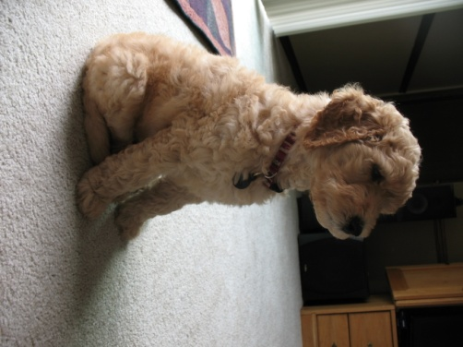

1.